**MDS ID Missing On Opportunity**

**Issue Description:** The MDS ID/SOR is missing for OHSR 1-XXXXXXX. OHSR 1-XXXXXXX is stuck in Draft-Action Required and not submitting.

**Troubleshooting and Resolution:**

There are few reasons for this type of issue to be occurred.

1. There is no Project released from ADOPT to ROME.
2. SOR creation might be stuck at an interfacing application.
3. Project is released before OHSR is created in ROME.
4. There is no OHSR present on Opportunity.
5. OHSR is created on Different Solution and Project is released on other (In case of multiple Solution on Opportunity).

Once found the category to which the issue belongs to, find below the Navigation path and Resolution Steps.

1. Go to Opportunity Screen, query with the opportunity id >> Solutions-ASAP tab >> find the solution number >> if only one solution is present >> Go to Admin-Sales order Request view >> Staged order view >> Query with the Solution ID present in Solutions ASAP tab >>
2. If there is a record present, check if the Order ID is present which is the MDS ID, else check reference II.
3. Else if there is no record, then ADOPT didn’t send project release notification to ROME. Ask BOA to check with ADOPT for the same.

Find below Screen Shots on how to check in UI, for Project release notification:

SS 1:



SS 2:

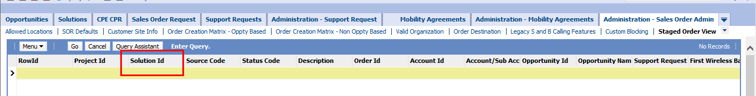

SS 3:

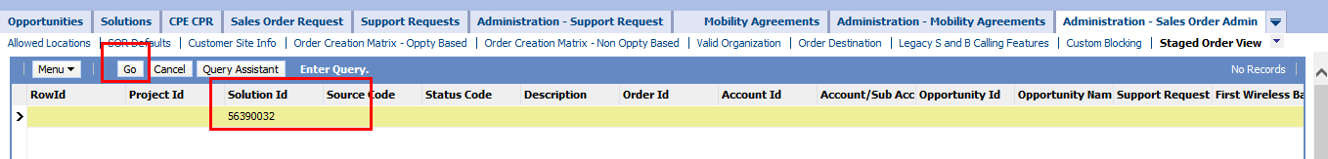

SS 4:

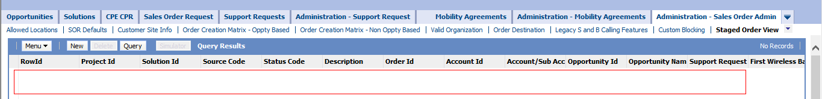

Logs to find if the project is released or not can be found under folder “**ProjectRelNotif**” in ADSL servers, please check them using Solution ID.

1. From above if you see there is a record present, no Order ID generated and under status code there will be an error. Check below for types of error:
2. Status Code: GCP data collection error, Description: No Opportunity record/Support Request was found with Solution Id.

SS 5:



The above error is generally seen if there is no OHSR present on the Opportunity by the time ADOPT released the project notification to ROME.

One of them from type III, IV, V might be the cause for this issue.

1. Project Release from ADOPT should be happened after OHSR is present in ROME. SOR/MDS resides on OHSR, so if the OHSR is not present on Opportunity when the project is released, there won’t be a SOR created.

In this type of issue OHSR will be generated after project is released.

Use below SQL queries to find out when was the Project is released and when OHSR is created.

select * from siebel.CX_STG_ORDER where row_Id = 'Staged Row ID from admin SOR view';

select * from siebel.S_EVT_ACT where row_id = 'OHSR ID';

1. If OHSR is missing on opportunity then SOR won’t be generated. Please refer to OHSR missing document for the reason behind OHSR is missing and what is the trouble shooting steps for the same.
2. This type of issue will be seen when we have 2 or more than Solutions on the opportunity. User might sign the contract on one solution and release the project on other. OHSR is generated based on solution. Both the solution on OHSR and project release should be same to create an MDS id.

To find the solution id on OHSR, go to OHSR >> More info >> ASAP! Information sub tab. (SS below).

SS 6:

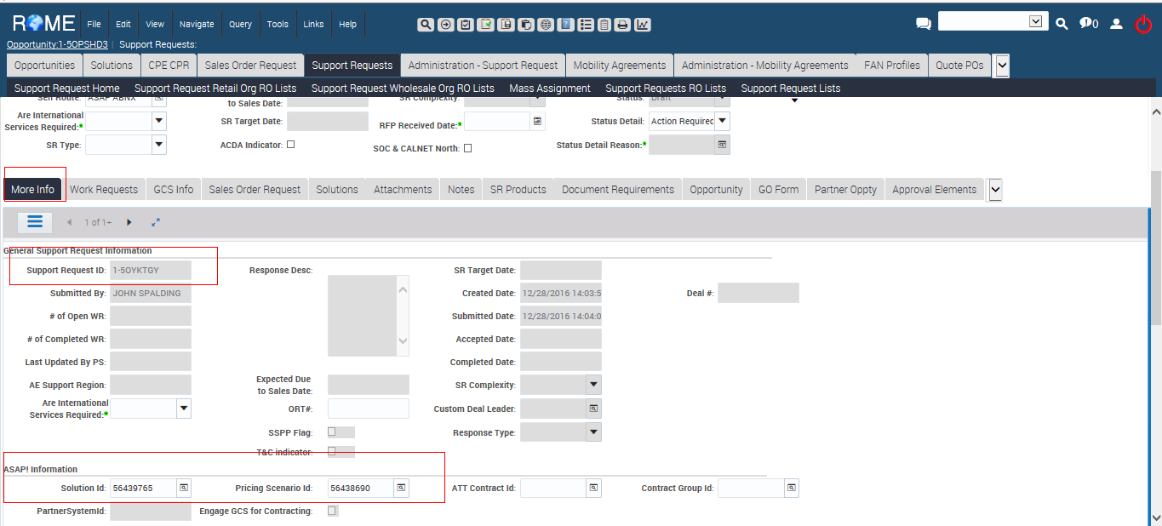

In this case if user wants the SOR on the solution they released the project we can change the Solution id on OHSR using a db script. But the contract should be on the same solution on which OHSR is going to be, as it may cause issue further in ordering.

Script for changing the Solution id on OHSR:

update siebel.S_EVT_ACT set X_SOLUTION_ID = 'Required Solution id' where row_id = 'OHSR ID';